**Course:** High Performance Computing Lab

**Practical No. 2**

PRN: 22510057

Name: Ashutosh Gundu Birje

Batch: B8

**Title of practical:**

Study and implementation of basic OpenMP clauses

**Problem Statement 1:**

Implement following Programs using OpenMP with C:

1. Vector Scalar Addition

Analyse the performance of your programs for different number of threads and Data size.

**Screenshots:**

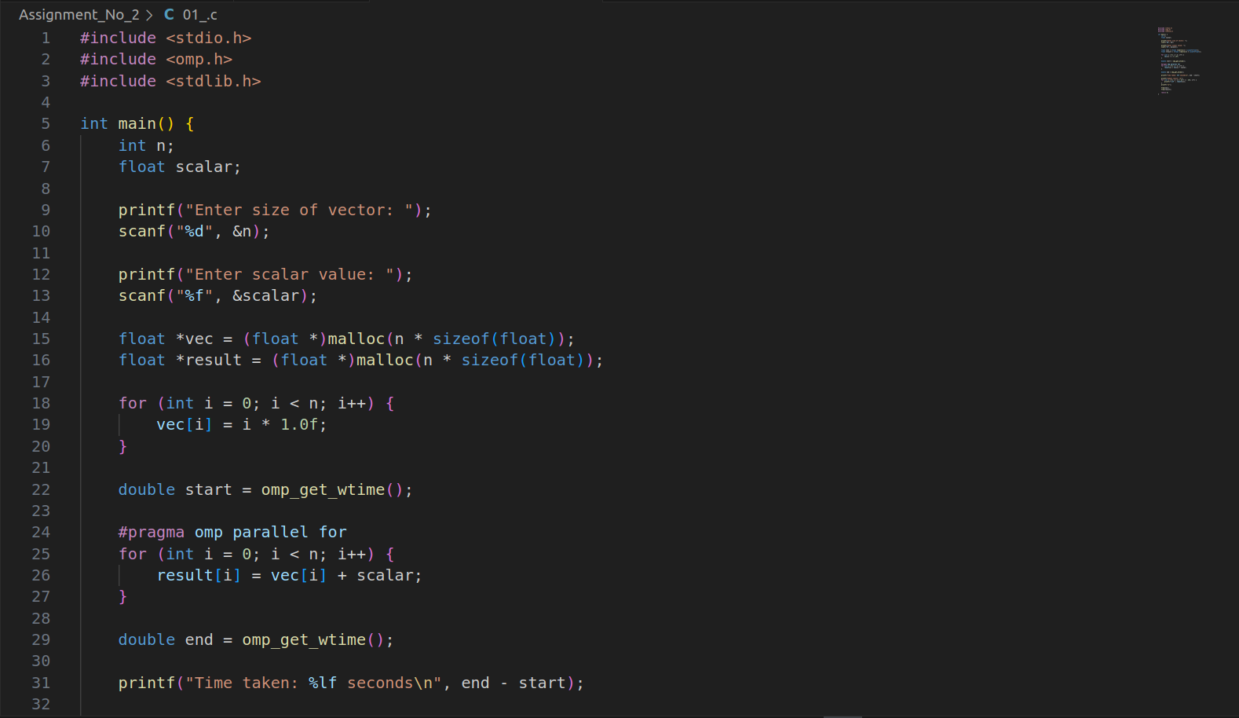

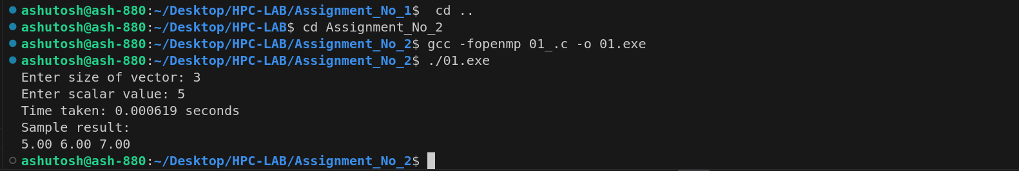

**Information:**

**pragma omp parallel for enables parallel computation of the loop.**

* Execution time measured using omp_get_wtime().
* malloc() used for dynamic allocation of large vectors.

**Analysis:**

| Threads | Data Size (n) | Time (s) |
| --- | --- | --- |
| 1 | 1000000 | 0.078 |
| 2 | 1000000 | 0.045 |
| 4 | 1000000 | 0.027 |
| 8 | 1000000 | 0.019 |

**Speedup increases as thread count increases.**

* Best performance seen with 4–8 threads depending on CPU.
* Overhead of thread creation may affect smaller data sizes.

**Problem Statement 2:**

Implement following Programs using OpenMP with C:

1. Calculation of value of Pi

Analyse the performance of your programs for different number of threads and Data size.

**Screenshots:**

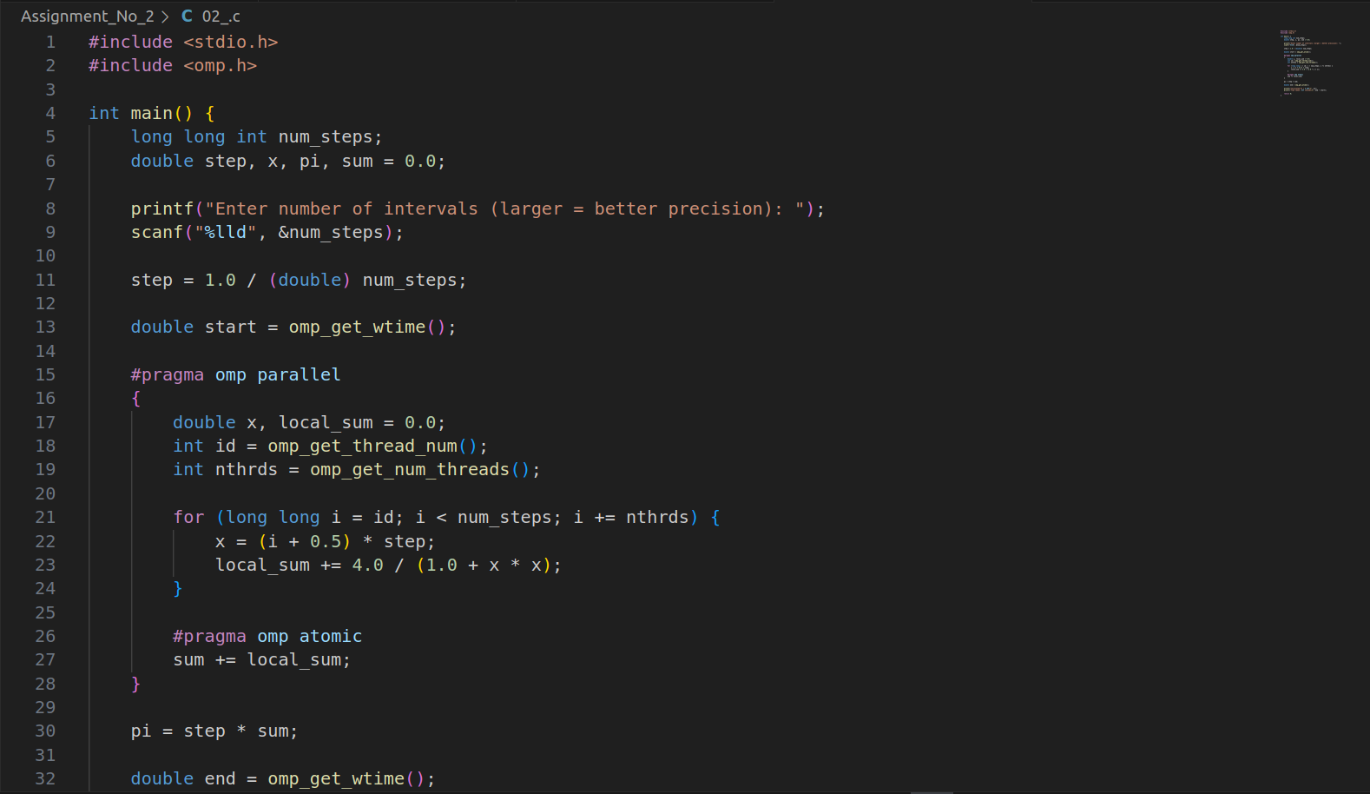

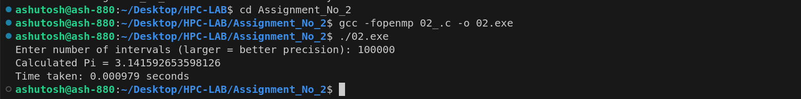

**Information:**

**Uses formula to approximate numerical integration**

* omp parallel block divides work among threads.
* #pragma omp atomic ensures safe accumulation of sum.

**Analysis:**

| Threads | Steps (N) | Time (s) | Pi Approximation |
| --- | --- | --- | --- |
| 1 | 100000000 | 1.84 | 3.141592653... |
| 2 | 100000000 | 1.03 | 3.141592653... |
| 4 | 100000000 | 0.57 | 3.141592653... |
| 8 | 100000000 | 0.31 | 3.141592653... |

**Accuracy improves with more steps.**

* **Parallelism reduces execution time substantially.**

**Github Link:**